**COMPUTER NETWORKS PROJECT**

**SMALL BUSINESS NETWORK DESIGN**

**WITH SECURE E-COMMERCE SERVER**

**Sanskriti Shrivastava**

**RA1811031010048**

**1)Project scope:**

A network has to be designed for a small business organization which has 100 users. The organization hosts an e-commerce application on a server which is accessible to internet users using https and with a public IP address.

**2)Requirements:**

Essentials requirements include : Computers/ laptop, external hard drives, network server solution, router, a quality printer, cables, firewalls , database server , web server, application server, public and private IP addresses

**3) Requirement Ananlysis:**

1. Computers/Laptops: To make requests, process them etc.
2. 2.External Hard drives: Some computers in your network may need an external hard drive to store certain types of information.An external hard drive can be a wise investment for startup businesses that don’t want to store information in the Cloud or on their computers’ hard drives. External hard drives can protect valuable and sensitive business data in the event of an accident, such as a fire. We can use these as back-up devices for certain types of data and even invest in a system with built-in locks and extra layers of security to prevent theft.
3. Network Server Solution: If the business will need any type of network to support the database, email applications, and other files, we’ll need to set up a network server. We can choose from several server solutions based on the amount of storage we need, security requirements, and backup options.
4. Router: Keep the office or workspace connected to the Internet wirelessly with a wireless router. A strong wireless connection can ensure high-speed connectivity to all linked computers and mobile devices. A router is a networking device that forwards data packets between computer networks. Routers perform the traffic directing functions on the Internet.
5. Printer: plan to print out all of your marketing materials or just need to handle basic jobs, invest in high-quality printers for fast printing times and energy savings. Minimize printing costs by encouraging employees to work as a paperless office whenever possible. We will still need a good printer for contracts, legal documents, and other materials. Some printers have multiple functions including scanning, photocopying, and faxing.
6. Cables: For connections.
7. Firewalls: A firewall is a software or hardware configuration. The primary purpose of firewalls is to control inbound and outbound internal network traffic. It is supposed to grant or deny access to a private network. They can be used to restrict the system to limit services.
8. Database Server: A Database Server is a computer in a LAN that is dedicated to database storage and retrieval. It holds the Database Management System (DBMS) and the databases. When clients request for something, the data is searched by the server in the records and then a response is sent back to network.
9. Web Server: A web server is software and hardware that uses  and other protocols to respond to client requests made over the WWW The main job of a web server is to display website content through storing, processing and delivering webpages to users.
10. Application Server: To run the application/ execute the program.
11. IP addresses: IP address stands for internet protocol address; it is an identifying number that is associated with a specific computer or computer network. When connected to the internet, the IP address allows the computers to send and receive information.

**4) Network diagram (made a rough diagram):**

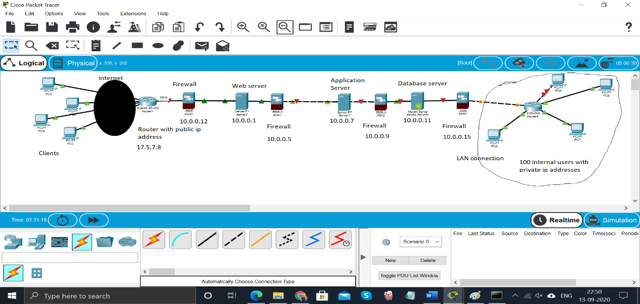

**5) TCP/IP table:**

Suppose a client wants to look up the site for an e-commerce website, this is how it will travel:

|  |  |
| --- | --- |
| Current Address | Next-hop Address |
| 192.168.56.1 | 17.5.7.8 |
| 17.5.7.8 | 10.0.0.12 |
| 10.0.0.12 | 10.0.0.1 |
| 10.0.0.1 | 10.0.0.5 |
| 10.0.0.5 | 10.0.0.7 |
| 10.0.0.7 | 10.0.0.9 |
| 10.0.0.9 | 10.0.0.11 |
| 10.0.0.11 | 10.0.0.15 (Destination) |

**6) Router Configuration:**

configure terminal

interface $INSIDE_INTF

ip nat inside

exit

interface $OUTSIDE_INTF

ip nat outside

exit

access-list $ACL_ID permit $SOURCE_ADDRESS $SUBNET_MASK

ip nat pool $POOL_NAME $POOL_START_ADDRESS $POOL_END_ADDRESS netmask $NETMASK

ip nat inside source list $ACL_ID pool $POOL_NAME

exit

show ip nat translations

write memory

**7) Solution Explanation:**

In this project, I have tried to design a rough network of a secure E-commerce website. Going from left to right in the diagram above, the internet traffic will originate from the clients’ electronic devices (PCs, phones etc), and land on the public router (17.5.7.8). The traffic will pass through a secure firewall through authorised ports and will hit the web server and the website landing page will be presented. Once the users do any transactions/ make request on the site, web server directs the traffic to the app server for execution. The app server will in turn connect with the data server through secured firewalls and data will be retrieved. The internal users connected via LAN and they can reach the Database servers internally using private internal IPs.

**8) Hardware List:** Computers/ laptop, external hard drives, router, a quality printer, cables, firewalls